Name:____________________________________________ Date:________________ Period: _______

Physics 514 Quiz #2: 1D Motion, Momentum (30 Points) Mr. Werman
Multiple Choice: Place the letter of the correct answer choice on the blank space provided. (2 Points Each)

_____ 3. Which of the following statements is TRUE about distance and displacement?
a. Distance is a scalar quantity, while displacement is a vector quantity.
b. Distance includes the direction, while displacement does not.
c. Displacement is always longer than distance.
d. Displacement can never be negative, but distance can.

____ 5. Which of the following situations best represents a negative displacement?
a. A cat stands on a tree limb.
b. A cat jumps from the ground onto a tree limb.
c. A cat jumps from a lower tree limb to a higher one.
d. A cat jumps from a tree limb to the ground.
_____ 6. Which of the following would be a step to decrease experimental uncertainty in the toy car experiment?
a. Using a different stopwatch for each trial
b. Measuring the car’s position once per trial
c. Taking multiple measurements of position over time
d. Releasing the car from a different starting position each trial

_____ 9. Select the answer choice below that contains ONLY vector quantities?
a. Velocity, Displacement, Time, Mass
b. Momentum, Speed, Displacement
c. Mass, Distance, Speed
d. Velocity, Momentum, Displacement

_____ 10. In which of the following cases would an object have the greatest momentum?
a. A 2 kg object moving at 1 m/s
b. A 5 kg object moving at 0.5 m/s
c. A 3 kg object moving at 2 m/s
d. A 1 kg object moving at 4 m/s

17. A 7.25 kg bowling ball traveling with constant speed hits the pins at the end of an 18.3 m long bowling lane. The bowler hears the sound of the ball hitting the pins 3.50 s after the ball is released from his hands. How much momentum does the ball have when it strikes the pins? (Note: the speed of sound is 343 m/s)
(10 Points)

16. The Flower Car starts at the -2 m mark driving with a velocity of +18 cm/s. At the same time, the Army Car is 5 m away on a path for a head-on collision traveling at 3.5 times the Flower Car’s speed. If both cars remain at constant speed, where will they collide? (10 Points)

18. The motion of a child pedaling a BigWheel tricycle (combined mass of 18 kg) is shown in the graph below. A second child riding a motorized PowerWheel truck starts is 9 meters away heading in the opposite direction at half the speed. They collide head-on and come to rest. (10 Points)
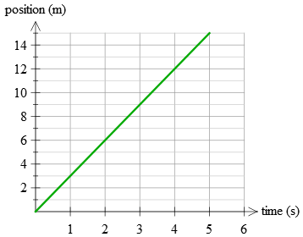
a) Sketch the motion of the PowerWheel truck on the graph.
b) What is the mass of the PowerWheel truck (with rider)

Bonus (3 points)
A father and son are driving separate cars to Penn State for move-in day. The father drives conservatively with a constant velocity of 55 mph, while the son sets a quicker pace of 62 mph. The son arrives at campus 18 minutes ahead of his father. How far was the trip?

